**Name :** Dhavalkumar Vijaykumar Patel

**Subject :** Essential of Cyber Security and Cyber Waefare

**Class :** M.Sc Cyber Security

**Semester :** 1

**Lab 8 :**

Packet Sniffing in Windows

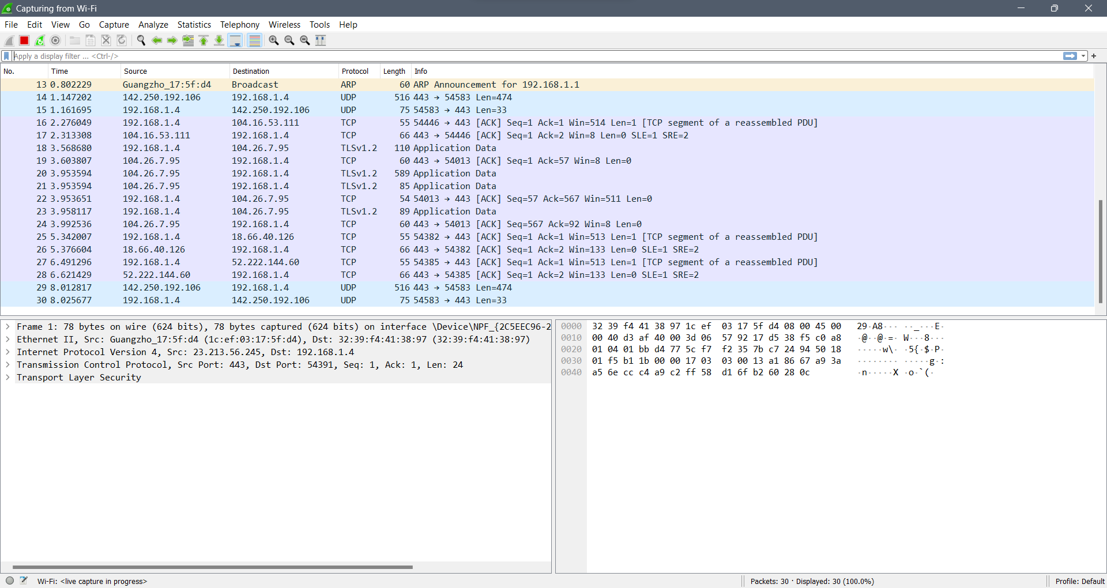

Packet sniffing in Linux

